A197-Afr-Egy-Ma‘at-Seated-Late Period, 664-332 BCE-Chlorite

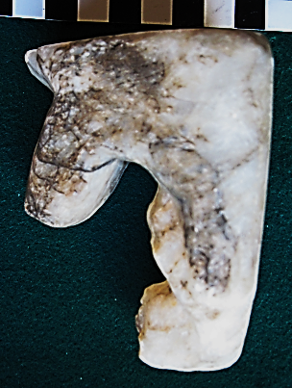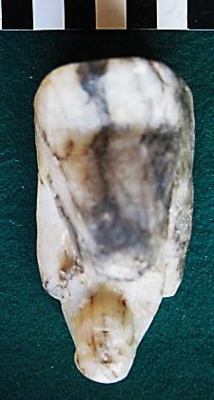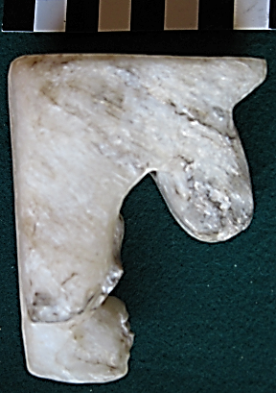

Figs. 1-3. Ma‘at-Seated-Late Period, 664-332 BCE-Chlorite

**Case No.: 2**

**Formal Label:** Maat-Seated-Late Period, 664-332 BCE-Chlorite

**Display Description: Seated figure of the goddess Maat sculpted in chlorite** in tripartite striated lappet wig, hands resting on the thighs, on a rectangular base.

**Accession Number: A197**

**LC Classification:** DT62

**Date or Time Horizon:** Late Period, 664-332 BCE

**Geographical Area:**

**Map, GPS Coordinates:**

**Cultural Affiliation:** Late Period, 664-332 BCE

**Medium:** chlorite

**Dimensions: H 89.30 mm; 3.52 in; W 48.49 mm, 1.90 in  
Weight: 289 gm; 10 1/8 oz**

**Provenance: unknown**

**Condition:** original

**Discussion:** Ma‘at **(***mˤ3t*) refers to the philosophical concepts of truth, balance, order, harmony, and justice, and the personification of these concepts as a deity that has the power of regulating stars, seasons, and actions both divine and mortal. This solid chlorite figurine suggests its power even though it is diminutive but very stable. Her feather was used by Thoth in the determination of whether a soul (measured by the heart) was lighter than it and therefore would reach afterlife successfully. This is why hearts were left in Egyptian mummies while their other organs were removed, as the heart (called "ib") was seen as part of the Egyptian soul. If the heart were equal or lighter to Ma‘at,’s feather, the deceased having led a virtuous life would go on to *Sekhet Aaru* () or "fields of rushes"where the Sun rises and where souls live for eternity. In these fields the laborers perform agricultural tasks for the noble deceased, in the form of Ushabti. The Coffin Texts emphasize the subterranean elements of the afterlife ruled by Osiris, in the Duat where afterlife is offered to everyone who reaches there, and where the deceased is referred to by his/her "Osiris-[name]". Coffin text 1130 is a speech by the sun god Ra, who says:

*Hail in peace! I repeat to you the good deeds which my own heart did for me from within the serpent-coil, in order to silence strife...*

*I made the four winds, that every man might breathe in his time...*

*I made the great inundation, that the humble might benefit by it like the great...*

*I made every man like his fellow; and I did not command that they do wrong. It is their hearts which disobey what I have said...*

*I have created the gods from my sweat, and the people from the tears of my eye.*

**References:**

Budge, Ernest Alfred Wallis. 1906). The Egyptian Heaven and Hell. London: Kegan Paul, Trench, Trübner & Co., Ltd.

De Buck, Adrian and Alan Gardiner, eds. 1961. *The Egyptian Coffin Texts*. Oriental Institute. Publications vol. 87. Chicago: Chicago U.P.; Cambridge: Cambridge U.P.

Faulkner, Raymond O. 2004. *The ancient Egyptian coffin texts.* Warminster: Aris & Phillips.